Multi-Threaded e-Commerce Program

CSE 445 - Assignment 2

2/18/2012

**This solo project was completed by Dave Hubbard.**

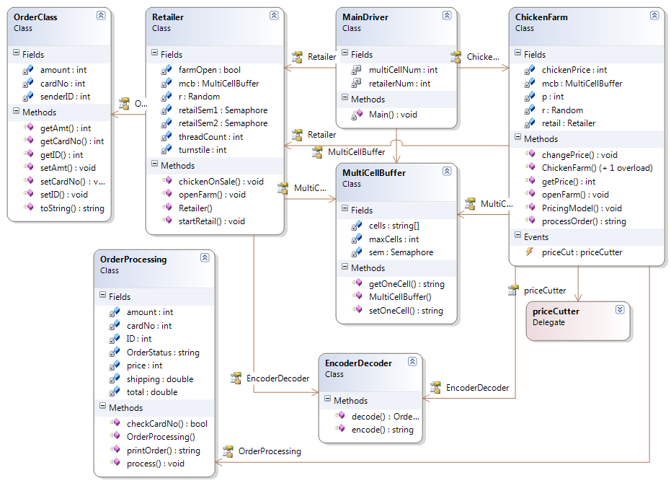**Class Diagram:**

**Performance Data (Intel Core 2 Duo @ 2.0GHz):**

|  |  |  |
| --- | --- | --- |
| Retailer Thread Number (N) | Average Order Response Time | Total Running Time |
| 1 | 00:00:00:24 | 00:01:02:02 |
| 2 | 00:00:00:06 | 00:01:02:02 |
| 3 | 00:00:00:16 | 00:01:02:02 |
| 4 | 00:00:00:08 | 00:01:02:02 |
| 5 | 00:00:00:20 | 00:01:02:02 |
| 6 | 00:00:00:22 | 00:01:02:02 |
| 7 | 00:00:00:12 | 00:01:02:02 |
| 8 | 00:00:00:18 | 00:01:02:02 |
| 9 | 00:00:00:13 | 00:01:02:02 |
| 10 | 00:00:00:07 | 00:01:02:02 |

**User Guide:**

-Created in Visual Studio 2010 using C#.

-Open the Visual Studio Project called "Assignment 2". Choose Start Debugging (F5)

-There are no inputs while the program is running. To set the number of Retailers and Buffer Cells, change the variables "retailerNum" and "multiCellNum" in the MainDriver.cs file.

-Output should show the current price of chickens set by the Chicken Farm every two seconds. A price cut event will cause the Retailers to start making orders. Output will confirm when an order goes out (showing number of chickens ordered), when it completes (showing total price), and how long it took. When the farm closes, the total elapsed time will be displayed. It's all pretty straightforward.

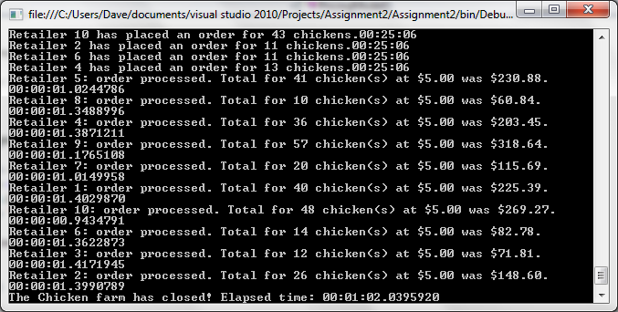**Screenshot:**